Burnished Velvet® The Punched Cardstock Shapes Process
Technique Created By Haroldine Wingfield and Deanna Pannell
*This Tutorial is not to be reproduced without permission

Completing The Punched Cardstock Border and the Punched Cardstock Shapes techniques FIRST, will help you to accumulate tape backing to use in technique #3 and #4.

Supply List:
-Glitter Ritz™ Black Microfine glitter
-Be Creative® 40MM Tape
-Be Creative® Fine Point Tweezers
-Be Creative® Precision Blade
-Be Creative® Glitter Magnet
-Punch Bunch flower and fern punches, McGill 1/8 and 3/16 circle punches (for flower centers)

Step 1: Cut Splash cardstock (Bazzill) to 5.5 x 8.5 inches. Score at 4.25 inches and fold the card. Lay 40 MM Be Creative tape on the card front ¼ inch from the fold. Turn card over and trim excess tape. Punch flowers and fern images from cardstock. Remove tape backing with tweezers.

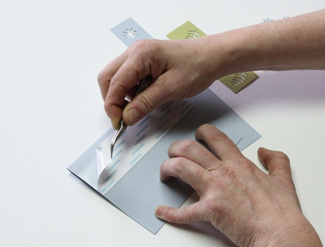

Step 2: Place flower and fern images alternately on the exposed tape using the tweezers. It is VERY important that you do not touch the exposed tape with your fingertips.

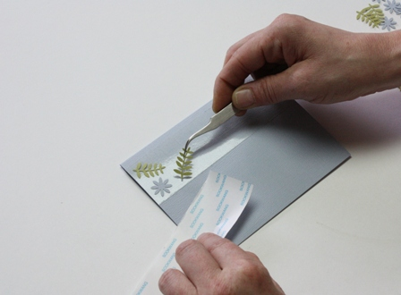

Step 3: Use tape backing to press the cardstock strip firmly and evenly to the tape.

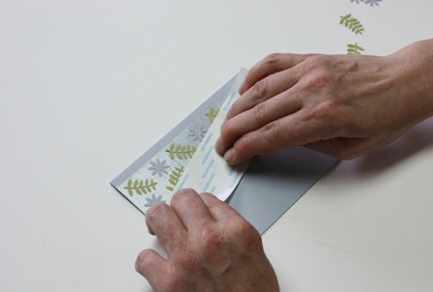

Step 4: Apply Black Microfine Glitter to the tape. Brush off excess glitter. Burnish with your fingertip by rubbing the glittered area firmly.

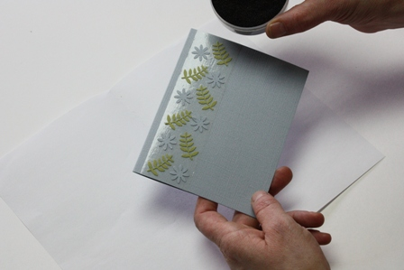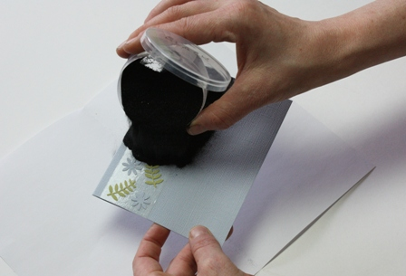

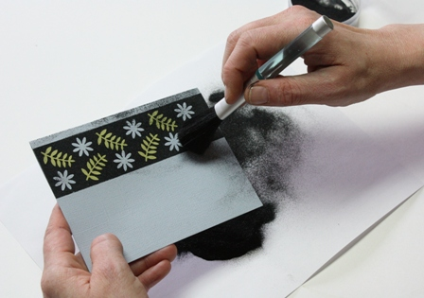

Step 5: Use Be Creative Glitter Magnet to clean excess glitter from your workspace. Note: Do not use Glitter Magnet on masks or paper.
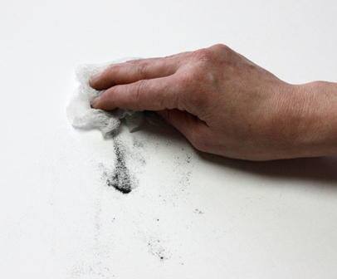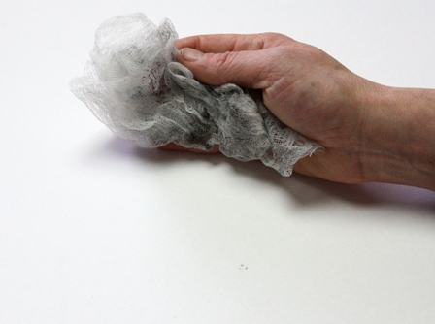
Mailing Tip: Place card inside plastic sleeve before the paper envelope to ensure your card arrives in perfect condition. The humidity in differing climates can affect the adhesive slightly.

